Nepal College of information technology

Level: Bachelor | Assessment Spring | Year : 2012
Programme: BE |  | Full Marks: 100
Course: Simulation and Modeling |  | Time : 3hrs.

Candidates are required to give their answers in their own words as far as practicable.
The figures in the margin indicate full marks.

Attempt all the questions.

 | - When time is not important in simulation, which model do you choose? Describe with examples.  - How Monte Carlo method is used in simulation describe with example? | 7  8
 | - What is CSSLs? Explain the CSMP III program structure.  - How simulation differs from analytical solution? What are the steps in simulation study? | 7  8
 | - Explain the various components of analog computer used in simulation. Would you like to use analog computer to simulate all kinds of systems? Give reasons. Draw the analog computer diagram to simulate a system whose behaviour is expressed by the following equations:  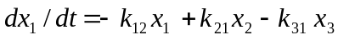  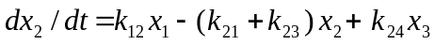  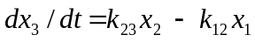  - Explain different time advance mechanisms in simulation with example. | 8  7
 | - What are the various types of calls? Simulate telephone system for lost call system  - Define different types of entities in SIMSCRIPT and how do you declare these entities? | 10  5
 | - What is feedback system? Explain the simulation of an auto pilot.  - Parts are being made at rate of one every 9 ± 3 minute. As they are finished, the parts go to an inspector who tasks 15 ± 3 minute to examine each part and reject 20% of the parts. Simulate it for 500 parts. Draw GPPS diagram and write code for the same.. Both inspectors reject about 10% of parts they inspect. Simulate it for 1000 parts. Draw GPSS diagram and write code for same. | 7  8
 | - "Replication of runs will refine simulation output". Justify this statement with statistical analysis.  - Describe the measuring utilization and occupancy with mathematical modelling. | 7  8
 | Write short notes on (Any Two):  - Analog Computer  - Endogenous and exogenous event  - Facilities and Storages | 5×2

